**DAILY ONLINE ACTIVITIES SUMMARY**

|  |  |  |  |  |  |  |  |  |
| --- | --- | --- | --- | --- | --- | --- | --- | --- |
| **Date:** | **01/07/2020** | | | | | **Name:** | **SUJAYA** | |
| **Sem & Sec** | **IV sem & B section** | | | | | **USN:** | **4AL18CS090** | |
| **Online Test Summary** | | | | | | | | |
| **Subject** | | **-** | | | | | | |
| **Max. Marks** | | **30** | | **Score** | | | **-** | |
| **Certification Course Summary** | | | | | | | | |
| **Course** | **Blockchain Basics** | | | | | | | |
| **Certificate Provider** | | | **Greatlearning academy** | | **Duration** | | | **2.5hours** |
| **Coding Challenges** | | | | | | | | |
| **Problem Statement1:**  Given two lists, sort the values of one list using the second list | | | | | | | | |
| **Status: Executed** | | | | | | | | |
| **Uploaded the report in Github** | | | | | **YES** | | | |
| **If yes Repository name** | | | | | **Online-coding** | | | |
| **Uploaded the report in slack** | | | | | **YES** | | | |

Online Test Summary: No internals conducted today.

Online Certification Course Summary: In today’s session I have learnt about the Blockchain Examples where is the blockchain technology used and one of the company where the technology used is Walmart and many other companies but Walmart is the popular.

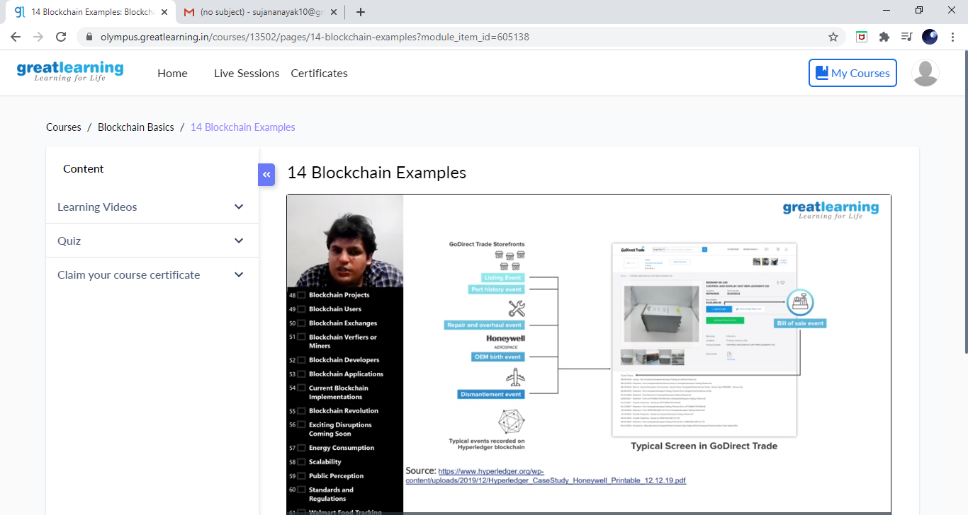

This is the snapshot of today’s session.

Online Coding Summary: : **Today I had received one program from prof. Vasudev CSE Dept. The program is mentioned above in the coding challenges. I have also uploaded it to my Github repository.**

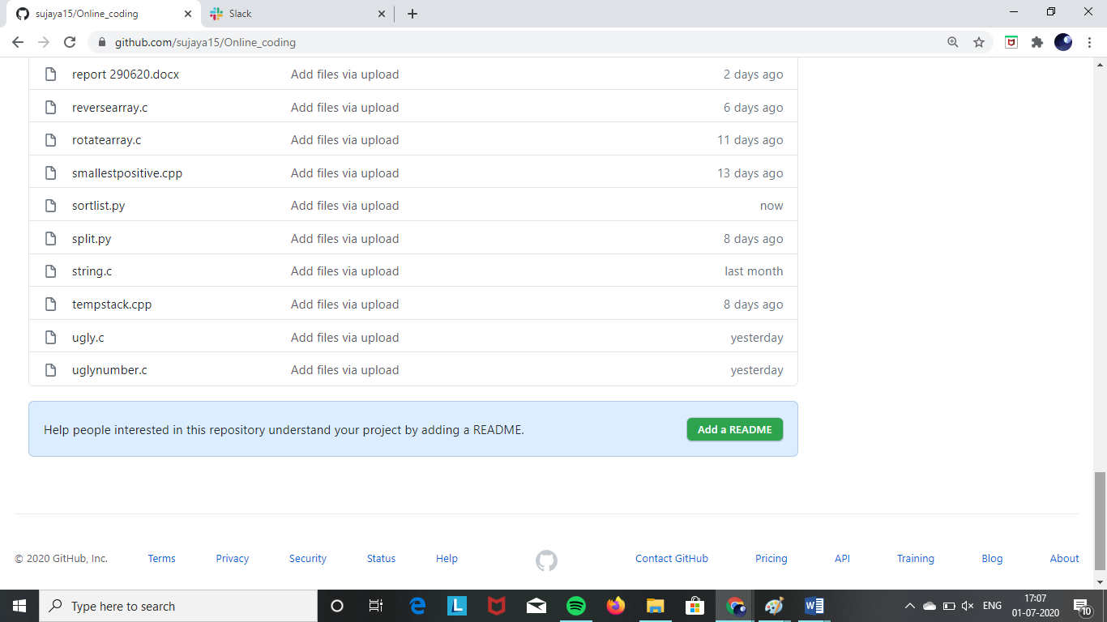

**This is the snapshot of my Github repository** were I have uploaded the code. File name is sortlist.py